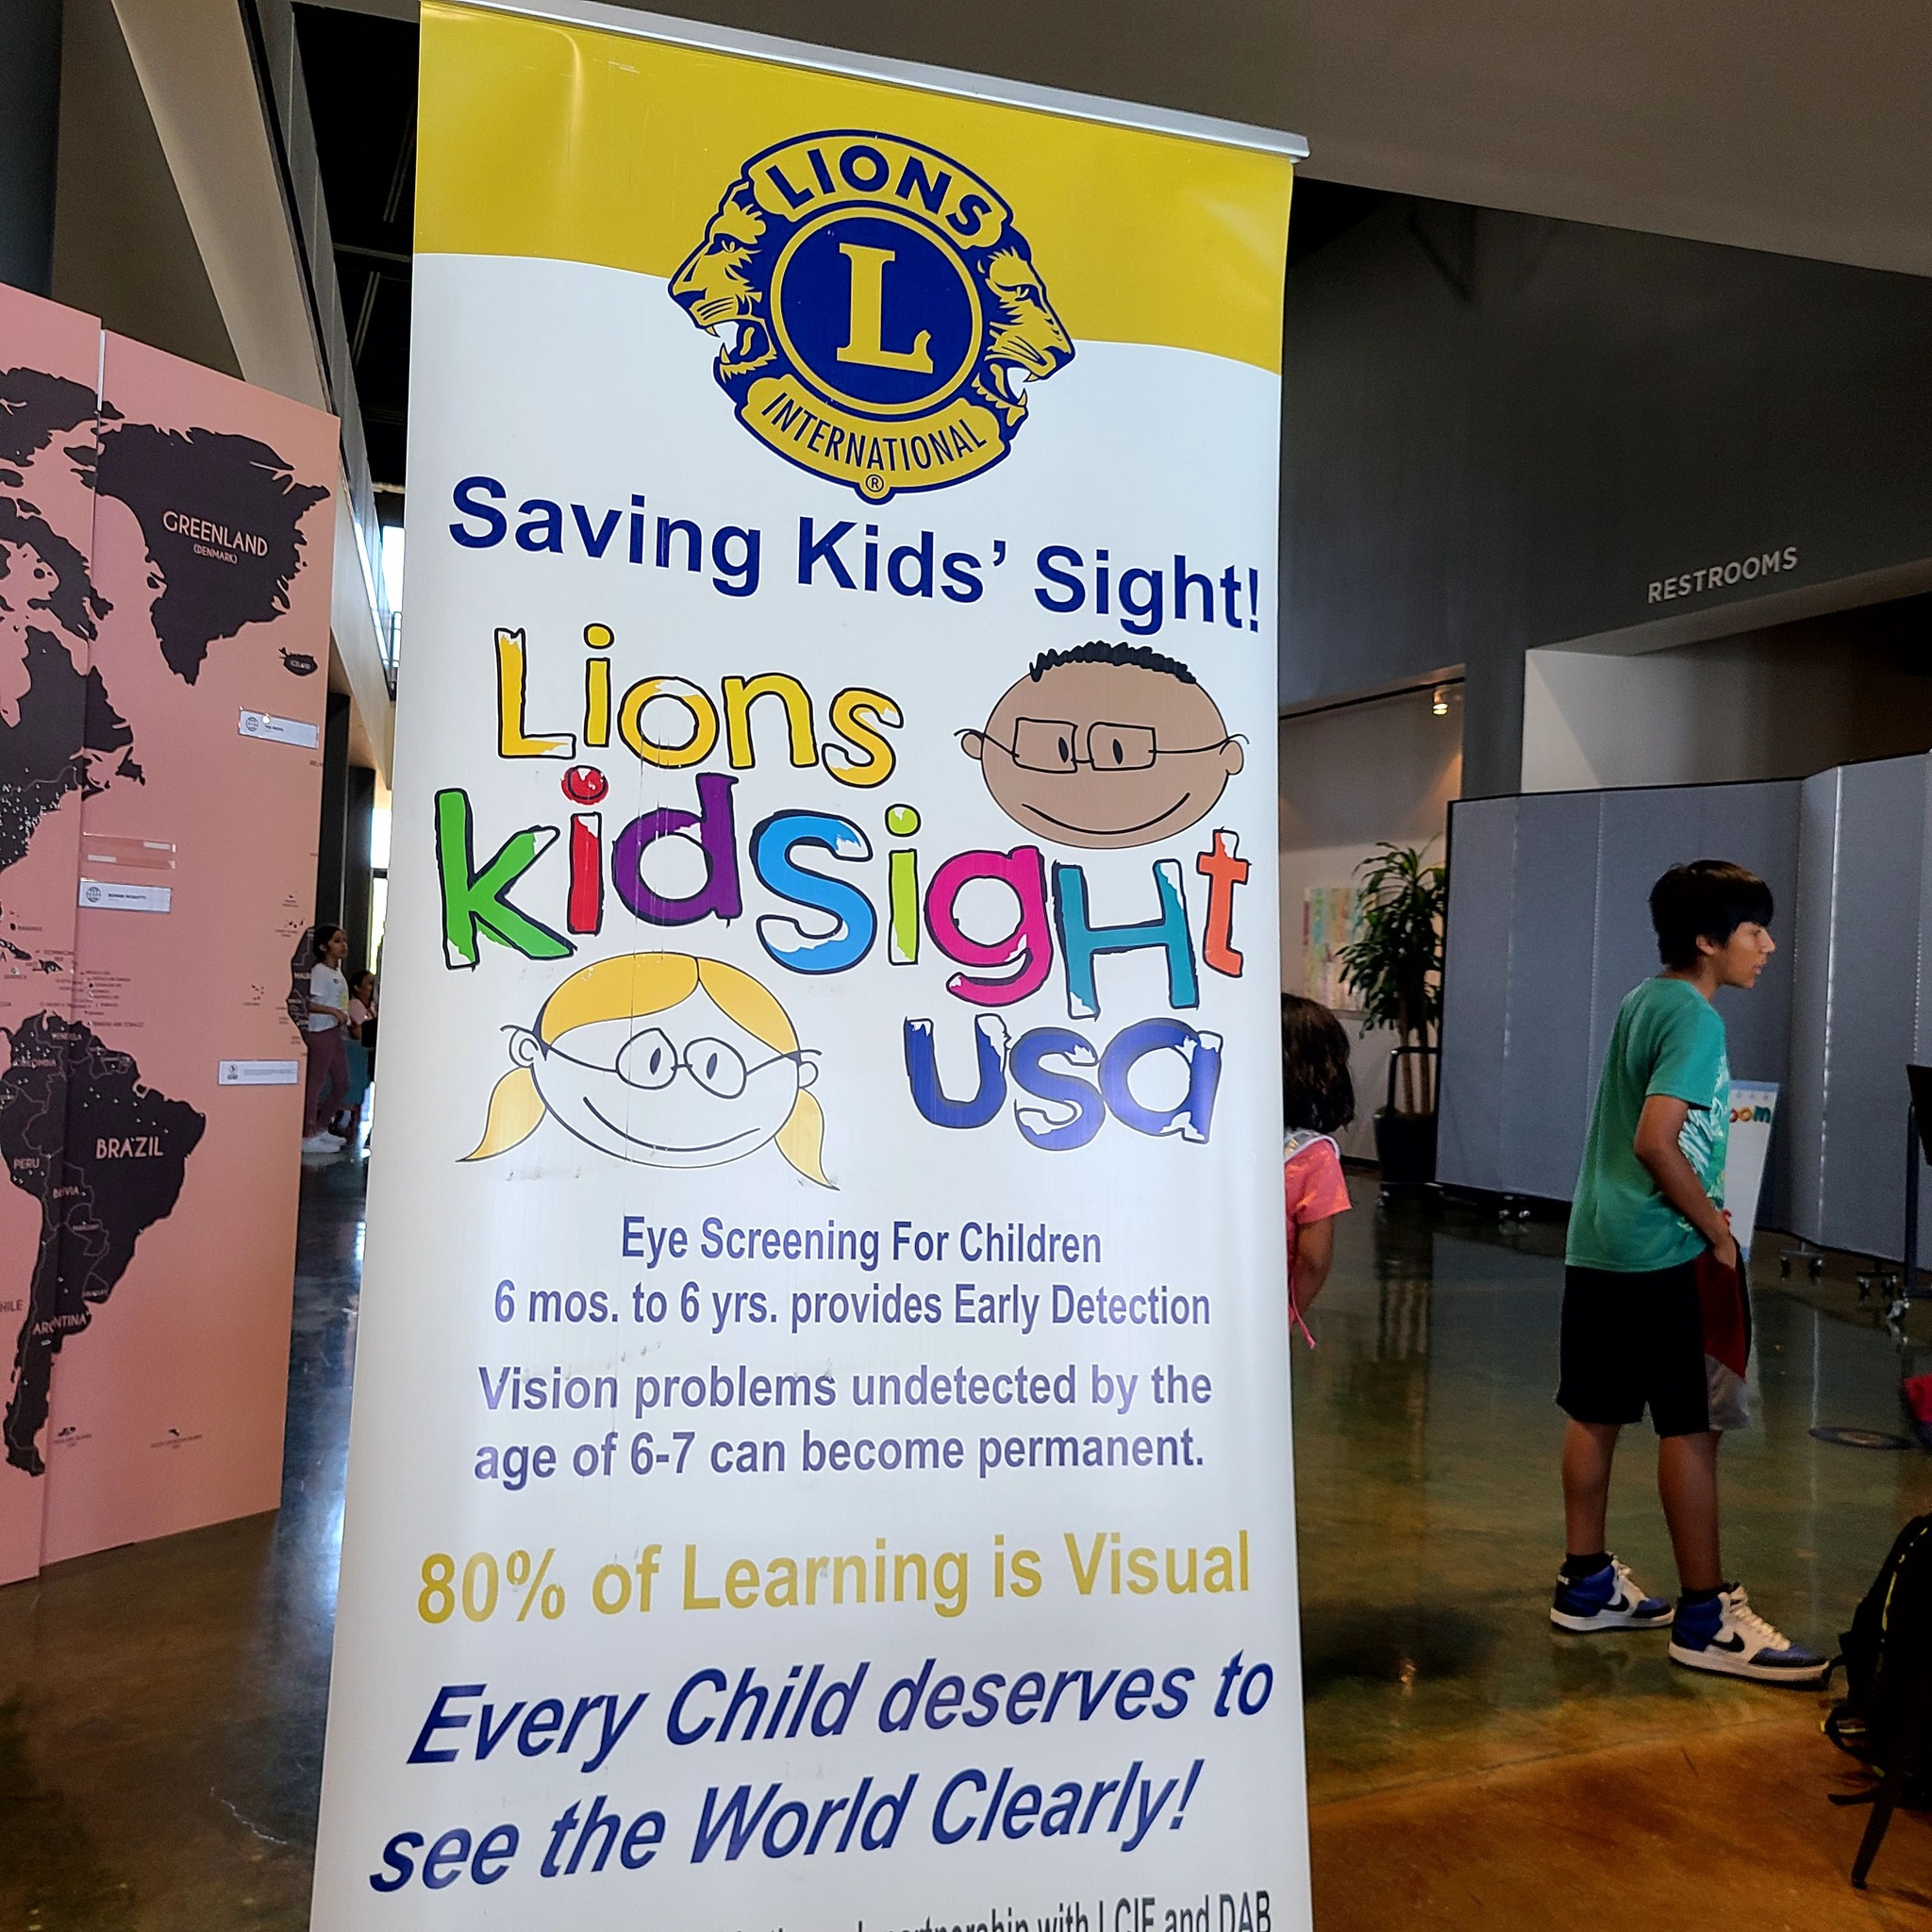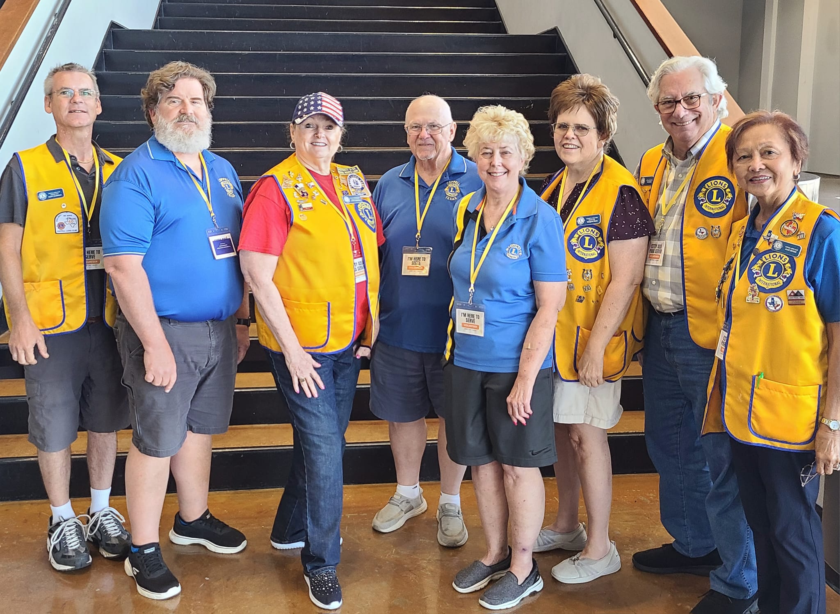

COPPELL LIONS CLUB VISION SCREENING FOR BACK TO SCHOOL

Coppell Lions Club were at the Back to School Fair at Irving Bible Church conducting Spot Vision Screening with the club’s Vision Screening Team led by Lions Tim Decker, Alice Decker, Ron Harrison, Kim Taylor, Kris Pollard, Margaret Meek, Scott Murdock and Debbie Goodwin. Great service project for the Lions. Students received uniforms, backpacks, school supplies, haircuts, Vision Screening, medical assessments and snacks.

