THE COPPELL LIONS CLUB SERVES WITH CITY PROJECT
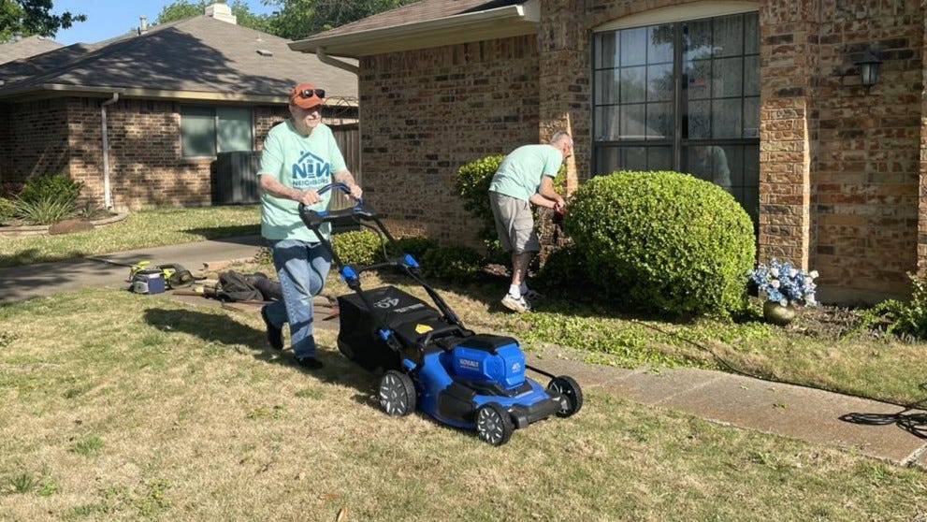Lion George Collier mowed grass at a house on Brooks Drive while Lion Scott Murdock trimmed the bushes.
More than 200 volunteers provided assistance at 61 homes during the city’s fourth annual Neighbors Helping Neighbors service project.
Four members of the Coppell Lions Club — George Collier, Lynn Cooper, Julie Madden, and Scott Murdock – trimmed bushes, cut grass, and poured mulch at a house on Brooks Drive.
Coppell Lions Club’s motto is “We Serve”. Want to serve with us? Check out our Facebook and Website page and get connected with the Lions Club.

