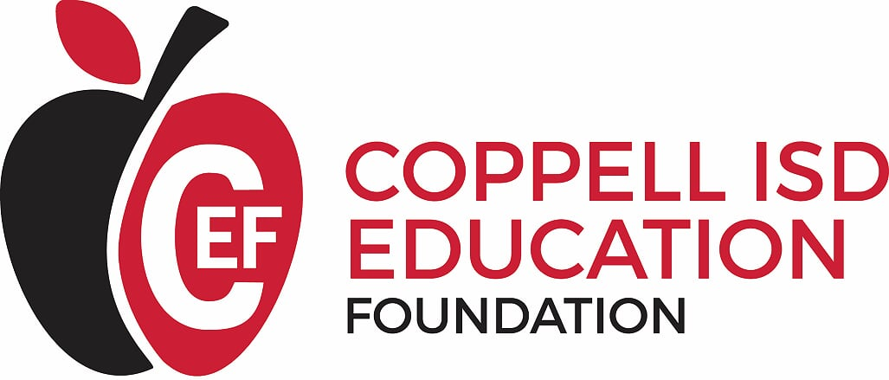

FOR IMMEDIATE RELEASE Contact: Angie Arthur
Email: aarthur@coppellisd.com Phone: (214) 496-6054

The Coppell ISD Education Foundation Seeks Candidates for Board of Directors
Board members will work together to support educational excellence and innovation
in Coppell ISD.
The Coppell ISD Education Foundation is seeking candidates to fill open seats on its Board of Directors for the 2019-2022 term. The mission of the Coppell ISD Education Foundation is to generate and distribute resources to the Coppell Independent School District for educational, motivational, and innovative programs to further the education for all students in Coppell ISD.
The Board is comprised of volunteers representing the community and businesses served by Coppell ISD. Board members oversee and implement all of CEF’s programs, including administering grants for innovative programs, student and teacher recognition events, educational camps, and individual and corporate fundraising. Board members also serve as ambassadors for CEF in raising community awareness and supporting the mission of excellence in education in Coppell ISD.
Those interested in serving as a board member can find more information about CEF and the board member application process at www.coppellisdef.com/get-involved. The deadline for submitting applications is March 29, 2019.
###
About The Coppell ISD Education Foundation
Chartered in 2000, the Coppell ISD Education Foundation is a non-profit organization of volunteers whose efforts have raised and donated more than $1 million in support of the schools, students and teachers of Coppell ISD. In 2018, CEF awarded over $48,000 in classroom grants as well as $11,750 in new teacher grants to first-time educators in Coppell ISD. To date, CEF has given over $1,127,000 to Coppell ISD. To learn more about the Coppell ISD Education Foundation, visit www.coppellisdef.com and follow us on Facebook and Twitter.

