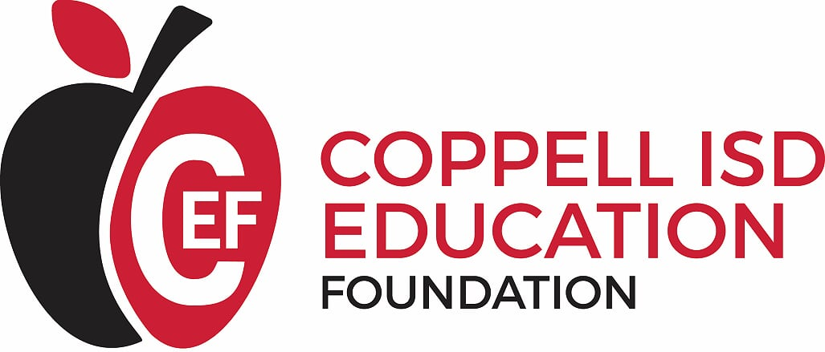
FOR IMMEDIATE RELEASE Contact: Angie Arthur
Email: aarthur@coppellisd.com Phone: (214) 496-6054
The Coppell ISD Education Foundation Honors Graduating Seniors, Teachers and Alumni at Annual Recognition Banquet
The Coppell ISD Education Foundation (CEF) held its annual Recognition Banquet on April 23, 2019 at the Embassy Suites in Grapevine. The event celebrated the graduating seniors in the top five percent at Coppell High School and New Tech High @ Coppell as well as Teachers of the Year from each Coppell ISD campus. In addition, four Distinguished Alumni were recognized for their accomplishments since graduating from Coppell.
This year, 43 Coppell High School and 4 New Tech High @ Coppell students were honored on this special evening. For the event, each senior invited a Coppell ISD teacher who made a positive impact on their academic career. At the banquet, the students were given the opportunity to honor their selected teacher by sharing how that teacher had impacted their educational experience. While the majority of honored teachers were from one of the high schools, there were two middle school and three elementary school teachers recognized.
Coppell ISD Superintendent Brad Hunt also announced the elementary and secondary district teachers of the year. Lee Elementary 5th grade teacher Samira Khan was named Elementary District Teacher of the Year, and Coppell High School Ninth Grade Campus science teacher Cathy Douglas was named Secondary District Teacher of the Year.
A new honor was recognized at the banquet this year. Coppell ISD introduced the Distinguished Alumni Award to recognize individuals who have attended Coppell High School, Victory Place @ Coppell, or New Tech High @ Coppell. They are outstanding leaders in their field and committed to service within their communities. Four well-deserving alumni, Dr. Toral Patel, Clay Phillips, Jacob Schick and Pete Wilson, embody these characteristics and received the very first Distinguished Alumni Award. To learn more about these honorees, please visit www.coppellisd.com.
###
About The Coppell ISD Education Foundation
Chartered in 2000, the Coppell ISD Education Foundation is a non-profit organization of volunteers whose efforts have raised and donated more than $1 million in support of the schools, students and teachers of Coppell ISD. In 2018, CEF awarded over $48,000 in classroom grants as well as $12,750 in new teacher grants to first-time educators in Coppell ISD. To date, CEF has given over $1,127,000 to Coppell ISD. To learn more about the Coppell ISD Education Foundation, visit www.coppellisdef.com and follow us on Facebook and Twitter.

