

Coppell Lions Club
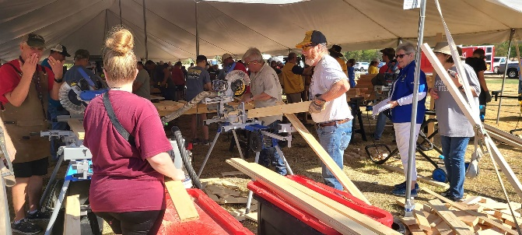
News Release
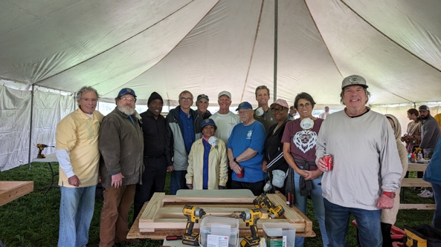
On Saturday March 16th, Coppell Lions Club members participated, along with members of other district Lions Clubs, in the Lions District 2-X1 wide “Build A Bed” Project to be held at the “Lions Park” in Waxahachie, Texas. The project is intended to build 75 wooden bed frames under the supervision of the “Sleep-In-Heavenly Peace” organization which supplies all the tools and setup. Lions supply the labor and the $18,750 in raw lumber and bedding materials using monies from the district and many of the 65 District 2-X1 Lions clubs located in Dallas, Ellis, Hunt, Kaufman, and Rockwall counties plus the cities of Allen, Plano, and Wylie in Collin County. Each bed also includes a mattress, pillow, and bed coverings for a total of $250 per bed.
Twenty-five of the beds will be given to the Texas Lions Camp for physically challenged children, located just south of Kerrville. The other 50 beds will be used by Sleep-In-Heavenly Peace to provide free beds to children in the DFW area who do not have a bed and must sleep on the floor or have other sleeping arrangements. All beds are provided free of charge.
This is the third such district wide bed build event in the last 12 months where a total of 350 other beds were built. Two hundred and fifty of those beds were given to the Texas Lions Camp to fill their new bunkhouses while the remaining 100 beds went to area children without a bed. The beds were built using money from the district Lions clubs and a matching grant from the Lions Clubs International Foundation (LCIF).
LCIF’s mission is to empower local Lions Clubs to accomplish humanitarian service that would not otherwise be possible without the support of their monetary grants.

